**CDAC Mumbai PG-DAC August 24**

**Assignment No- 4**

1) Write a program that demonstrates widening conversion from int to double and prints the result.

2) Create a program that demonstrates narrowing conversion from double to int and prints the result.

Code:

import java.util.*;

public class Integertodoub {

    public static void main(String args[]){

    int a = 54;

   double result = a;

   System.out.println("Widening conversion from int to double: " + result);

   double b = 324.6543;

   int result2 = (int) b;

   System.out.println("Narrowing conversion from double to int: " + result2);

}

}

3) Write a program that performs arithmetic operations involving different data types (int, double, float) and observes how Java handles widening conversions automatically.

Code:

import java.util.*;

public class Integertodoub {

    public static void main(String args[]){

  /*   int a = 54;

   double result = a;

   System.out.println("Widening conversion from int to double: " + result);

   double b = 324.6543;

   int result2 = (int) b;

   System.out.println("Narrowing conversion from double to int: " + result2);

}*/

int a = 43;

double b = 54.4332;

float f = 32.654f;

double result = a + b + f ;

System.out.println("Result of arithmetic operations: " + result);

}

}

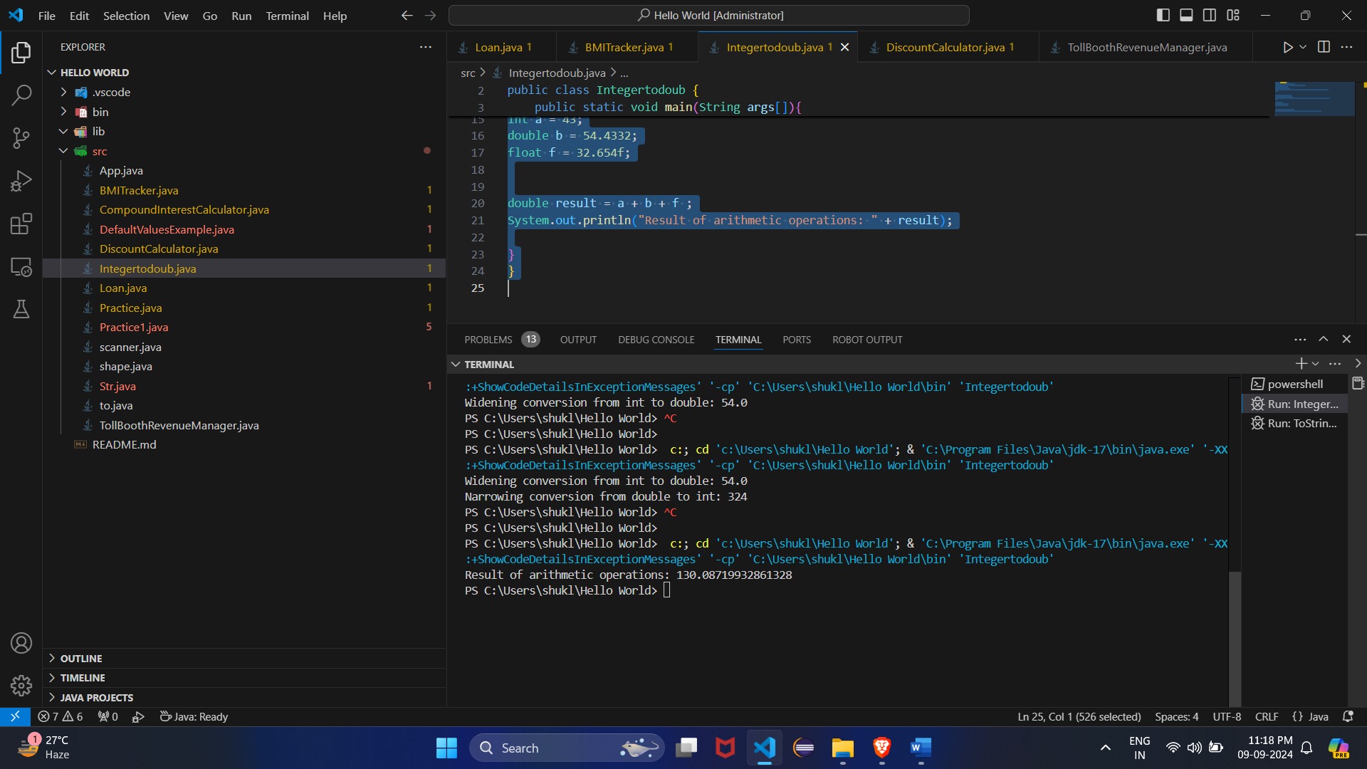

4) Write a Program that demonstrates widening conversion from int to (double,float, boolean, string) and prints the result.

Code:

public class WideningConversionExamples {

public static void main(String[] args) {

int num = 10;

// Widening conversion to double

double doubleVal = num;

System.out.println("Widening conversion to double: " + doubleVal);

// Widening conversion to float

float floatVal = num;

System.out.println("Widening conversion to float: " + floatVal);

// Conversion to String

String strVal = Integer.toString(num);

System.out.println("Conversion to String: " + strVal);

// Conversion to boolean based on condition

boolean boolVal = (num > 0);

System.out.println("Conversion to boolean: " + boolVal);

}

}

**Interview Questions**

**Note: Write down this interview question on your notebook ,Take a screenshort & Paste that SS in the word document & upload on your Github.**

**What does the static keyword mean in Java? Explain the difference between static and non-static methods.**

1. What is the role of the static keyword in the context of memory management.
2. Can static methods be overloaded and overridden in Java?Howstatic variables shared across multiple instances of a class?
3. What is the significance of the final keyword in Java?
4. What are narrowing and widening conversions in Java?
5. Provide examples of narrowing and widening conversions between primitive data types.
6. How does Java handle potential loss of precision during narrowing conversions?
7. Explain the concept of automatic widening conversion in Java.
8. What are the implications of narrowing and widening conversions on type compatibility and data loss?